Recliner
Recliner

Before you are discharged home from the hospital, we strongly recommend that you have a fully automated recliner (lift chair recliner) to sleep in for at least 6 weeks. This allows your abdominal incision to heal without pulling, and prevents you from rolling on your side while you sleep. The recliner should be able to recline with our pulling on a handle, and pushing back or using your legs to force it to return to a seated position.

Sleep Position

After transitioning back into the bed, you may find it more comfortable to sleep with your head elevated on extra pillows and two pillows under your knees to decrease the tension in your abdominal area. You should only sleep on your back and avoid sleeping on the reconstructed breast flap for at least six weeks.

Recliner Information

If you do not already own a recliner, you may find it helpful to rent a recliner for the short time that it will be needed. Below, we have listed some local businesses that rent recliners. Most will deliver to your house or hotel. They will also pick up the recliner when it is time to return the item.

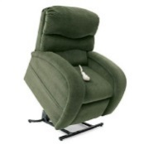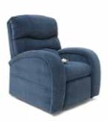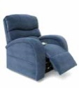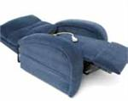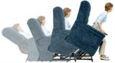

Where to Rent or Purchase Recliner
Texas Medical Supply  1906 West 18th Street  Houston, TX 77008  713-864-7636 or 713-893-4537  Monday-Friday 9 AM – 5 PM  Saturdays 10 AM – 2 PM  Rental and Delivery Available  www.txmedicalsupply.com | Houston Medical Supplies  9029 Westheimer Road  Houston, TX 77063  713-777-2244  Monday-Friday 8 AM – 6 PM  Saturdays 10 AM- 5 PM  Sunday 12 Pm – 4 PM  Rental and Delivery Available  $55 medium week/$155 month  (Holds up to 300 lbs)  $75 large/$185 month. (Holds up to 375lbs)
Horizon Medical Equipment  2236 West Holcombe  Houston, TX 77030  713-839-1420  Monday-Friday 9 AM – 5 PM  Saturdays 10 AM – 2 PM  Delivery available  $150 for 2 week, 200 for one month + delivery (starts at $50 up to 300 lbs.) | Excellent Medical Services  2807 Old Spanish Trail, Suite B  Houston, TX 77054  713-440-9800  Monday-Friday 9 AM – 5 PM  Saturday 10 AM – 2 PM  Rental and Delivery Available  $150 for one month  (up to 500 lbs. at $200 month)
Rent- A-Center
800-665-5510
www.rentacenter.com
Delivery available

